Lab Week 1
Name: Fill in your name here
We are going to start by exploring some careers of ocean researchers and some basic ocean facts.
You will do to two different locations on a NOAA website, pick categories, and play the multimedia files and read the indicated text. Then answer the questions thoroughly, add your answers to the document and highlight or change the text color so it is easy to see. Log back into blackboard and got to the lab section. Pick on the Turn in Lab 1 and upload the text document by Sept 9th, 2020.
Goto the Ocean Careers page
https://oceanexplorer.noaa.gov/edu/oceanage/welcome.html
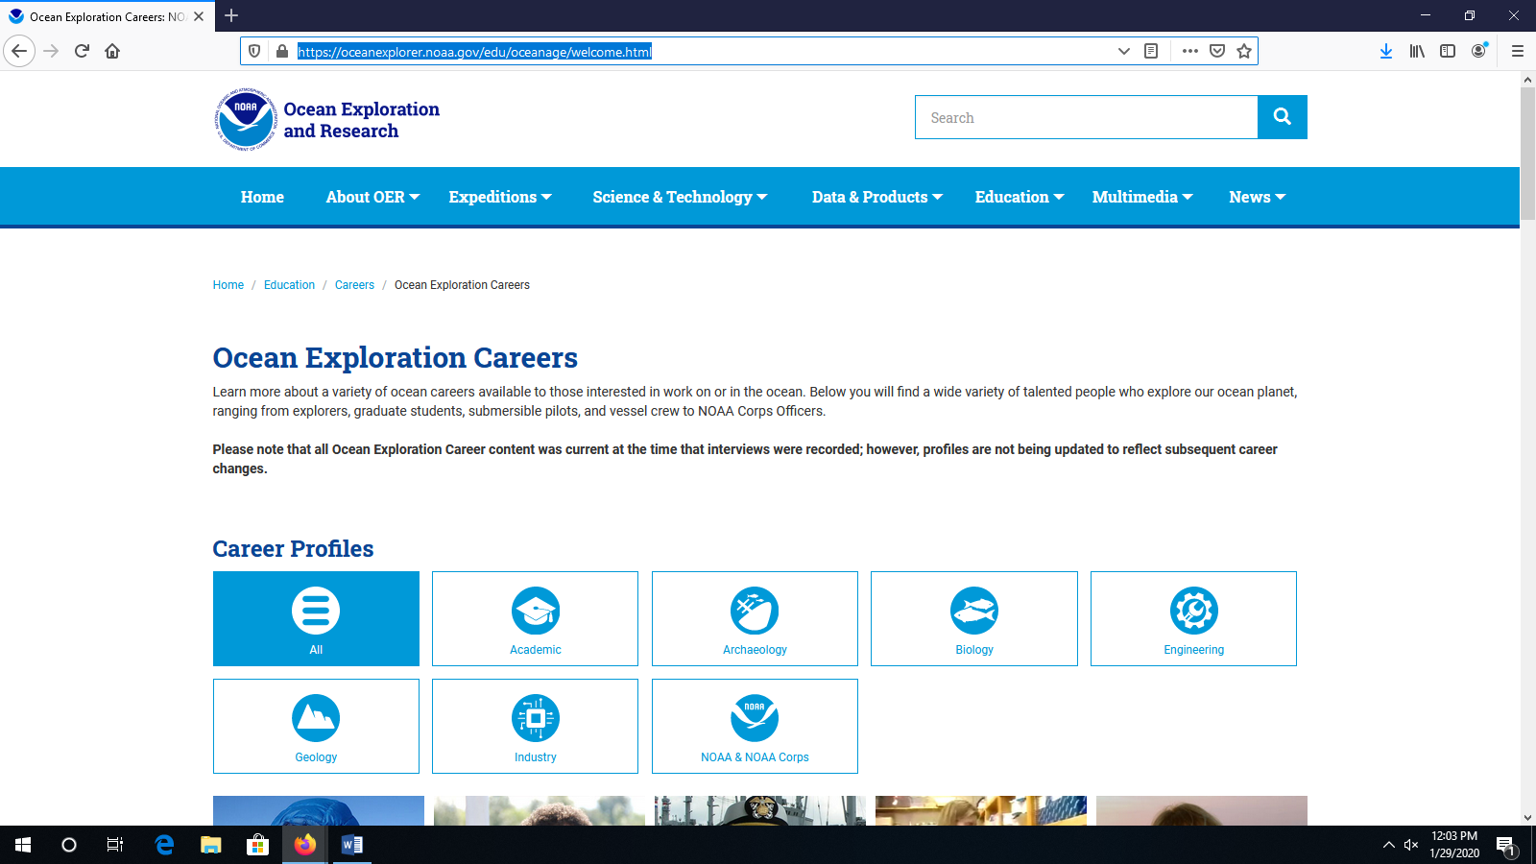

Look at the pictures of the researchers and pick three that interest you (you can also pick the career categories to see which researchers to what short of jobs).
Watch the interview of each researcher and read their biographical information. Answer these questions for each researcher (9 answers total):
- Why did this person get started in ocean exploration?
- Why do you think they are featured on this website?
- What parts of their research can you imagine yourself doing?
Goto the Explorer’s in training page.
https://oceanexplorer.noaa.gov/edu/explorer-in-training/welcome.html
Pick 3 of the students from the page and read there interviews, then answer the following questions for each student (9 answers total):
- Where is this student going to school?
- Why did they want to do ocean research?
- What skills / classes would you need to learn to do this type of research?
Goto the Ocean Facts page
https://oceanexplorer.noaa.gov/facts/facts.html
Pick Geology, Archaeology, Multibeam bathometry, plus two other categories to gather facts from (Total of 5):
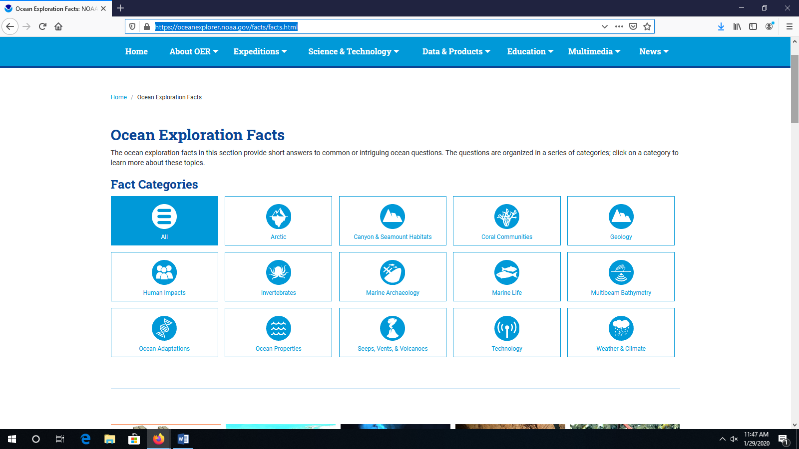
Answer these questions from the 3 listed categories and the two others you choose (10 total answers)–
- Geology – How big is the ocean (area and volume)?
- Geology – What is the best known hotspot?
- Geology – How does the ocean control the temperature of the air?
- Multibeam Bathometry – What is bathometry data collected?
- Multibeam Bathometry – How were ocean depth measurement collected in 1854?
- Multibeam Bathometry – How are temperatures collected in a column of water?
- Marine Archaeology – Other than shipwrecks, what types of sites interest marine archaeologists?
- Marine Archaeology – Make up a question base on the USS Monitor.
- Make up a short answer question from one of the other categories.
- How is the information presented in one of the other categories directly related to your daily life?

